

Mt. Zion United Methodist Church
41 Ark Road, Lothian, MD 20711
Pastor Marvene Young
ORDER OF WORSHIP
Sunday, September 14, 2025
Fourteenth Sunday after Pentecost
Liturgist: Sis. Penny Farmer

Praise & Worship: Male Chorus
Greeting & Announcements: Sis. Penny Farmer
To Our Visitors: Welcome to Mt. Zion United Methodist Church. Thank you for worshiping with us on this Sunday morning. We recognize that where one worships is an individual choice. We thank God that you elected to join us in this hybrid worship service and count it among our blessings. As we keep you in our prayers, may the grace of God continue to bless and keep you.

Call to Worship:

Lead: We come seeking refuge in a world where goodness and good news can feel far away.

People: God is our hope and our refuge.

Lead: We come searching for safety in a world that often calls foolishness wisdom and wisdom foolishness.

People: God is our hope and our refuge.

Lead: We come longing for rest in a world that bombards us with all the ways people work against the abundant life and flourishing of their neighbors.

People: God is our hope and our refuge.

Lead: Come, children of God, to find refuge and hope in God who delivers and restores us.

All: May God teach us and guide us to find refuge and be refuge with and for our neighbors today and every day.

Hymn of Praise: “I Surrender All” UMH #354 Congregation

Opening Prayer: Sis. Penny Farmer
Prayer Hymn: Male Chorus

Offertory Prayer: Sis. Natalie Hope
Information on Tithes and Offerings: Sis. Natalie Hope
Offertory: Congregation
All things come of thee, O Lord; and of thine own have we given thee. AMEN


Scripture Lesson: Psalm 14 Sis. Gloria Parker
Sermonic Hymn: Male Chorus
Sermon: “Give Thanks With a Grateful Heart!” Pastor Marvene Young
Invitation to Christian Discipleship: Pastor Marvene Young
Invitational Hymn: Male Chorus
Benediction: Pastor Marvene Young

Closing Hymn: Male Chorus



The Administrative Council will meet on September 18th at 6:30 p.m. via the church's Zoom site. All church members are welcome to attend. Please contact Bro. Johnny Drake regarding agenda items or if you need anything.

*Pastor Marvene will be the Guest Speaker, at Union UMC, Lothian, MD for Family and Friends Day, Sunday September 28, 2025 at 3:00 p.m.

*World Wide Communion Sunday will be held here at Mt. Zion on Sunday, Oct. 5, 2025 at 10:00 a.m. More information will be provided at a later date.

The Bible Study Class has completed its course of study for the year. Classes will resume in January 2026.

United Women in Faith’s praise and fellowship meeting, Saturday, September 20, 2025 at 9:30 a.m.

Men’s Prayer meeting is held on the 2nd and 4th Tuesdays at 6:30 p.m. Zoom Site: Meeting ID 820 6565 3545; Password: 162661

To give your tithes and offering using Zelle, search for MtZionArkRdFinance@gmail.com. To send your tithes electronically via PayPal, download the app from Google Play Store on your Android cell phone or from the App Store on your iPhone. Once you have accessed the app, search for #301-943-6432 to submit your tithes. A reminder is given that there will be a surcharge if tithes are submitted using a charge card. There is no surcharge for payments made through a bank account.

Father, we pray today for those home bound. We ask that you send your healing power down upon them and make them whole. Comfort them, O
Lord, and cause them to feel your presence and love. Strengthen them in your word and the promise of eternal salvation through Your Son, Jesus Christ.” Amen.

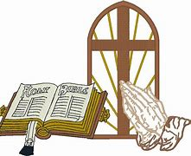

Sis. Bessie Abel (home)
Sis. Gloria Barnes (home)
Bro. Clifton Brown (home)
Sis. Myrtle Brown (home)
Bro. Oliver Fortune (home)

Sis. Jean Johnson (home)
Bro. Sam Johnson (home)
Sis. Annie Mae Mason (home)
Bro. Ron Silva (home)
Sis. Frances Turner (home)

Vision Statement

To grow in our relationship with Jesus Christ through ministry, support to and for one another, to the community and to the world.

Mission Statement

C- Connect with the community and the world to be one in the body of Christ.
O- Offer Jesus Christ to the world through ministry, teaching and preaching
of the Gospel.
M- Make disciples for Jesus Christ by the way we live, love, and share the
Gospel guided by the power of the Holy Spirit.
E- Exalt Christ the Savior through praise and worship.
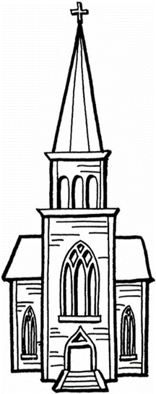
*************************************************************************************

Pastor Marvene Young’s Contact Information:
Phone #: (301) 873-2711
Email: pastormarveneyoung@outlook.com

Daily Prayer:
Righteous Father, thank you for your love and forgiveness. Now, dear Father, help me as I seek to draw closer to you and as I seek to know you better. Purify my heart of any duplicity or secret sin. Cleanse my conscience and empower me to be an example of your grace and holiness. In Jesus’ name I pray. Amen



